Week 2 results

Most effort of this week are focused on implementing online version algorithm and study its performance.

1. Files on different storage system (SSD/HDD)  
   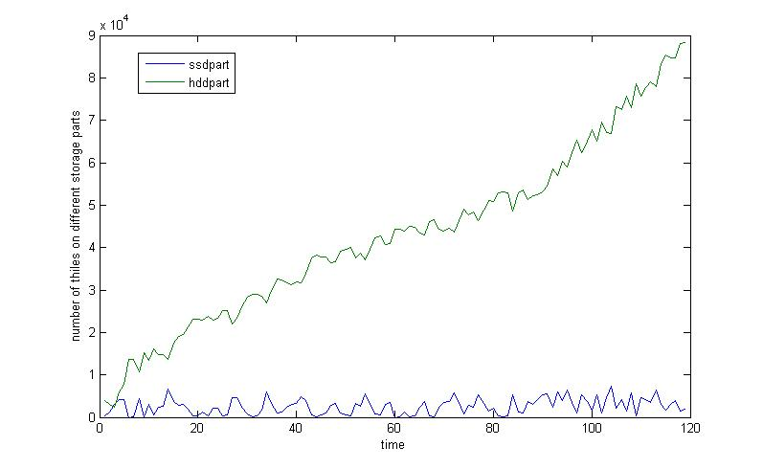
2. Accesses from different storage system  
   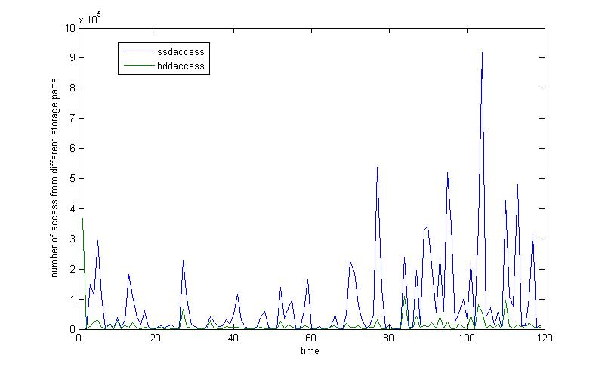
3. Data movement  
   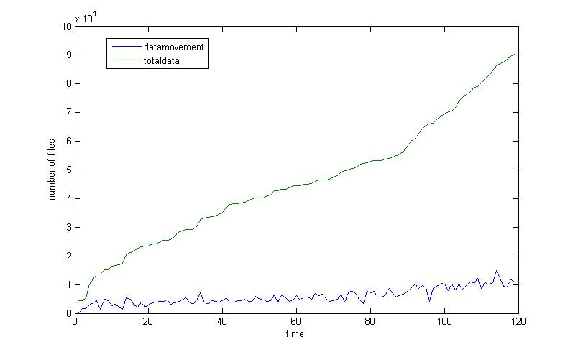
4. Threshold changing  
   